HDOC -day 13
Prepare the algorithm and test case table. Then write, compile, execute, and test the C program against the prepared use cases.
Write a menu-driven C program using switch-case to input a positive integer and perform one of the following operations based on the user’s choice:
- Count the number of even digits, and odd digits. E.g. Number: 12045, Even_dig = 3, Odd_dig = 2
- Find the sum of its even digits and the sum of its odd digits separately. E.g. Number: 12345, Sum_even = 6, Sum_odd = 9
Question 1: Count the number of even digits and odd digits.

Algorithm
1)Start.
2)Input a positive integer n.
3)Display the menu:
4)Count even and odd digits
5)Find sum of even and odd digits
6)Input the user's choice.
7)Use switch(choice).
8)If choice is 1:
9)Set even = 0 and odd = 0.
10)Take each digit of the number using % 10.
11)If digit is divisible by 2, increase even.
12)Otherwise, increase odd.
13)Remove the last digit using / 10.
14)Display even and odd digit counts.
15)If choice is 2:
16)Set sum_even = 0 and sum_odd = 0.
17)Take each digit using % 10.
18)If digit is even, add it to sum_even.
19)Otherwise, add it to sum_odd.
20)Remove the last digit using / 10.
21)Display both sums.
22)For any other choice, display Invalid choice.
23)Stop.
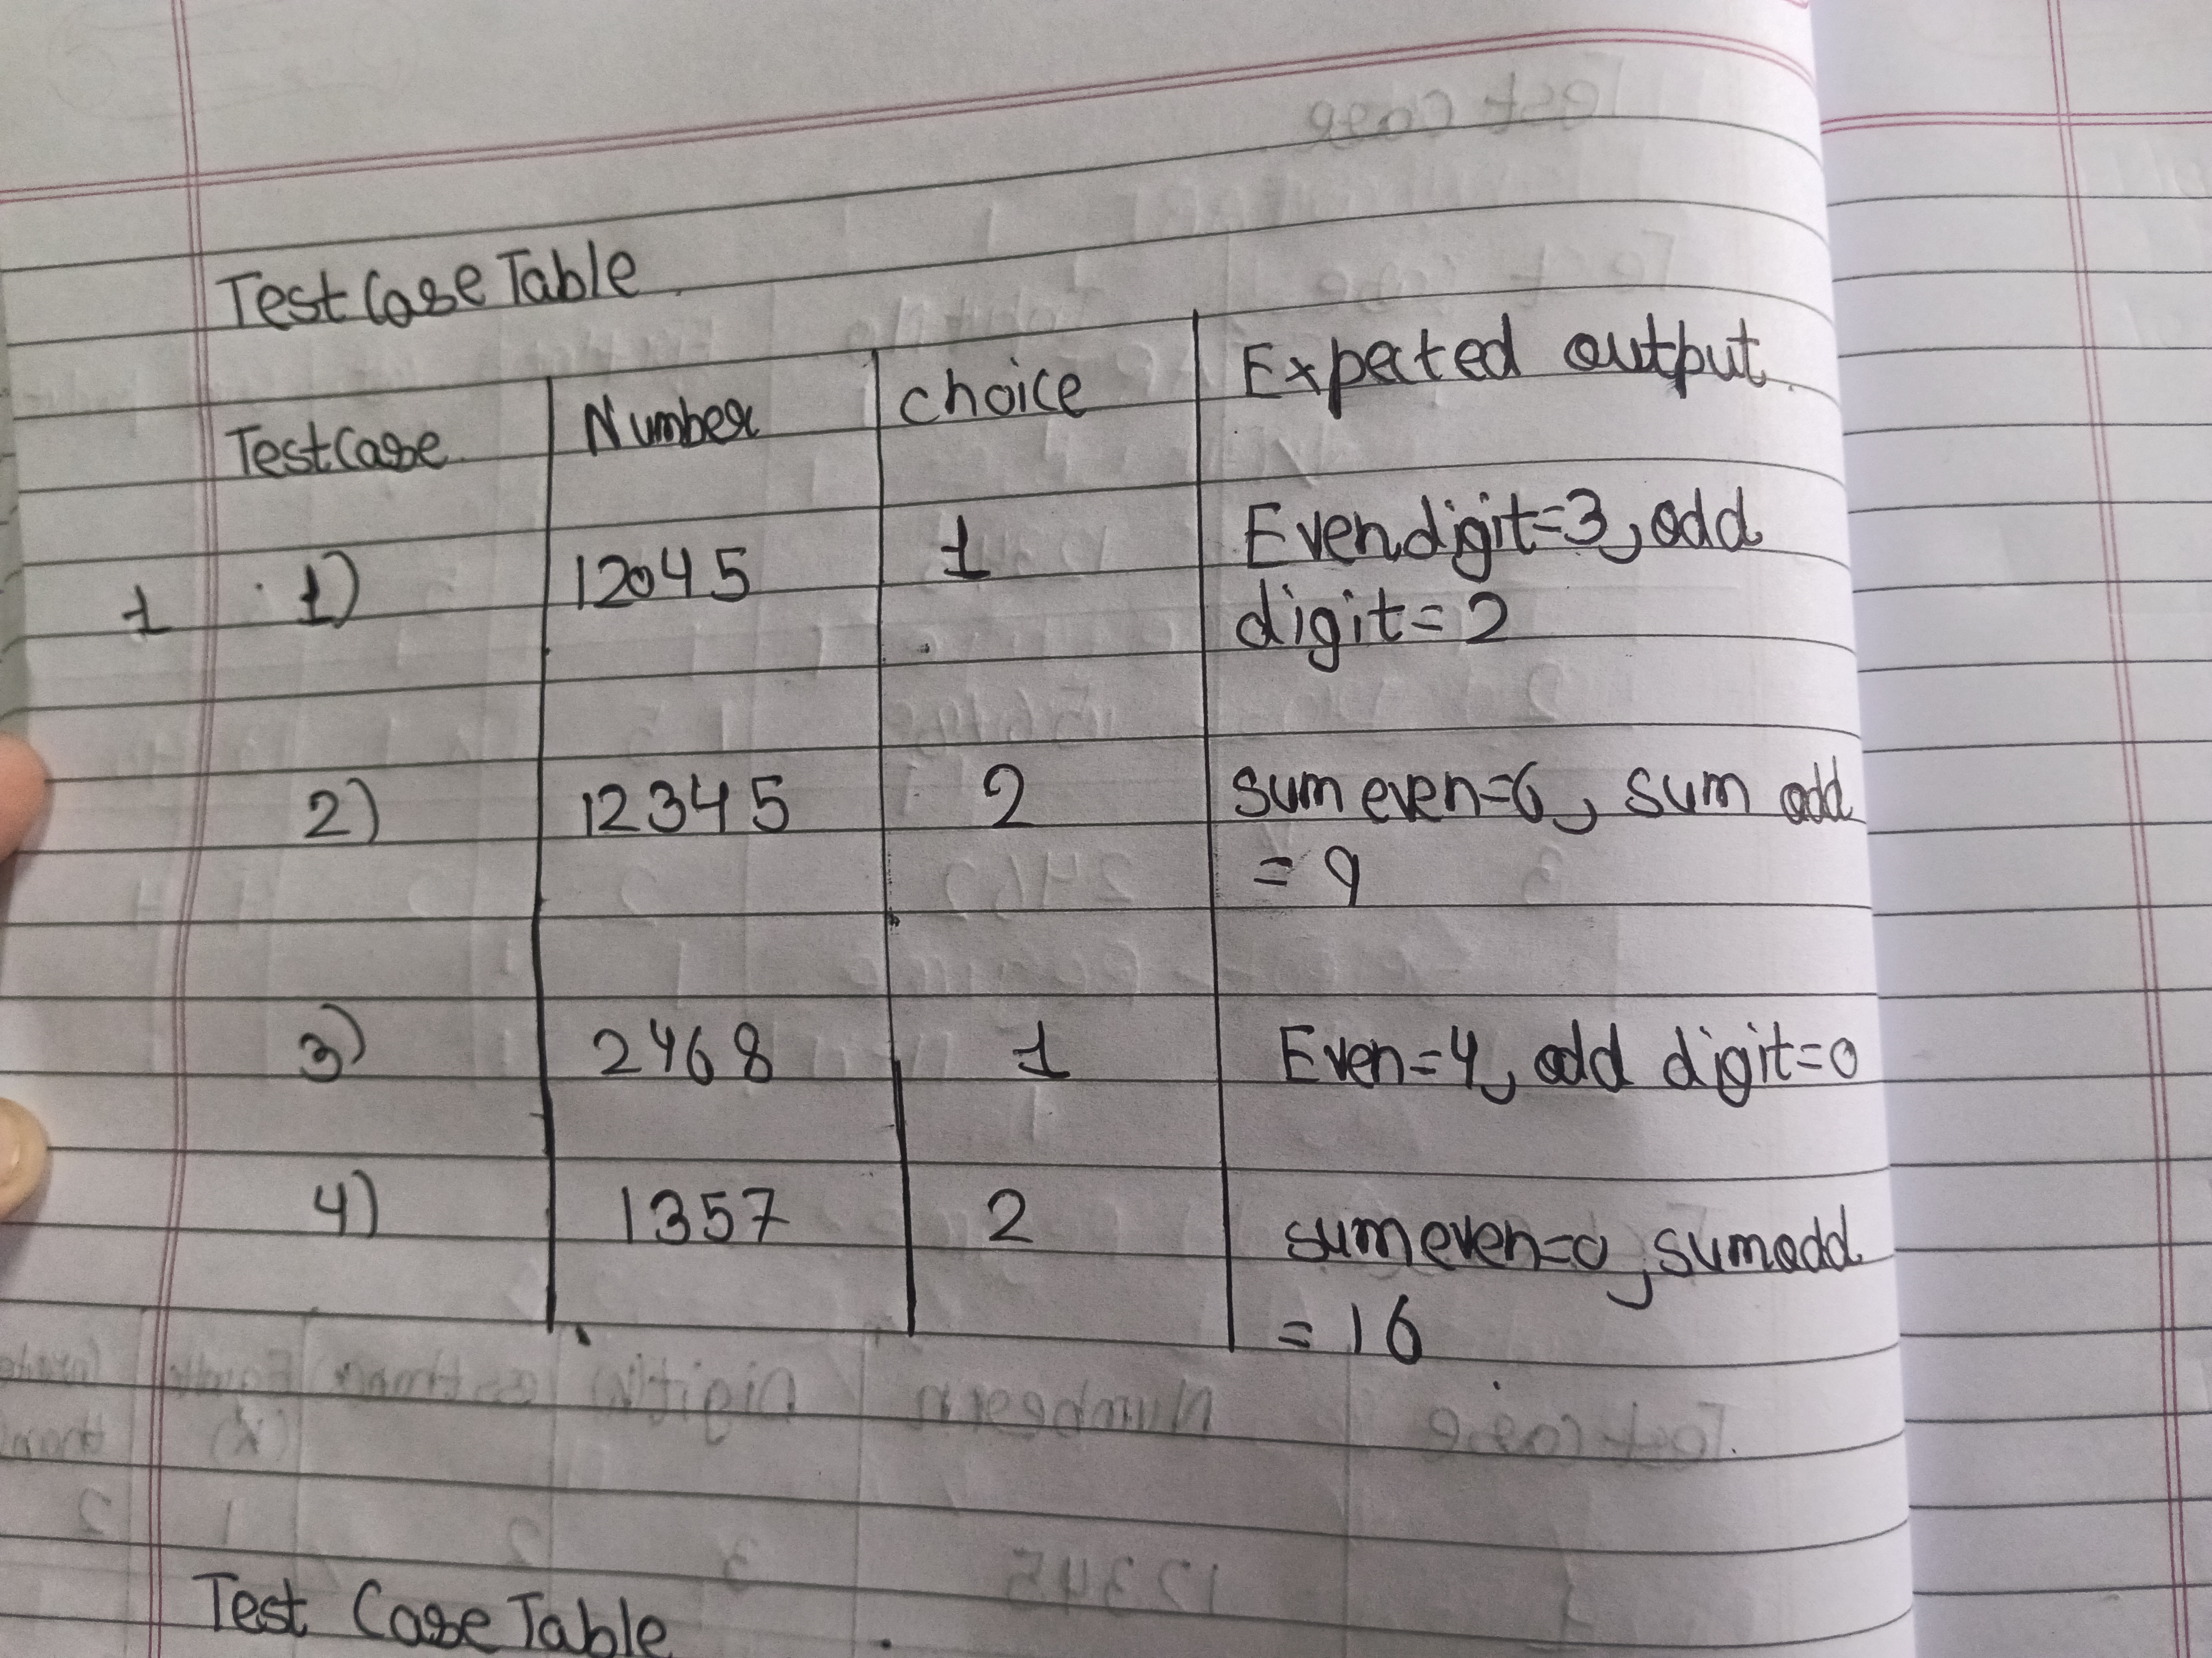
C code
#include <stdio.h>

int main()
{
int n, num, choice, digit;
int even = 0, odd = 0;
int sum_even = 0, sum_odd = 0;

printf("Enter a positive integer: ");
scanf("%d", &n);

printf("\n1. Count even and odd digits");
printf("\n2. Sum of even and odd digits");
printf("\nEnter your choice: ");
scanf("%d", &choice);

num = n;

switch(choice)
{
case 1:
while(num > 0)
{
digit = num % 10;

if(digit % 2 == 0)
even++;
else
odd++;

num = num / 10;
}

printf("Even digits = %d\n", even);
printf("Odd digits = %d\n", odd);
break;

case 2:
while(num > 0)
{
digit = num % 10;

if(digit % 2 == 0)
sum_even = sum_even + digit;
else
sum_odd = sum_odd + digit;

num = num / 10;
}

printf("Sum even = %d\n", sum_even);
printf("Sum odd = %d\n", sum_odd);
break;

default:
printf("Invalid choice");
}

return 0;
}

2)Find the sum of even digits and the sum of odd digits separately.
Algorithm – Sum of Even and Odd Digits
Start.
1)Input a positive integer n.
2)Set sum_even = 0 and sum_odd = 0.
3)Find last digit: digit = n % 10.
4)If digit is even, add it to sum_even.
5)Otherwise, add it to sum_odd.
6)Remove last digit: n = n / 10.
7)Repeat steps 4–7 until n > 0.
8)Display sum_even and sum_odd.
9)Stop.
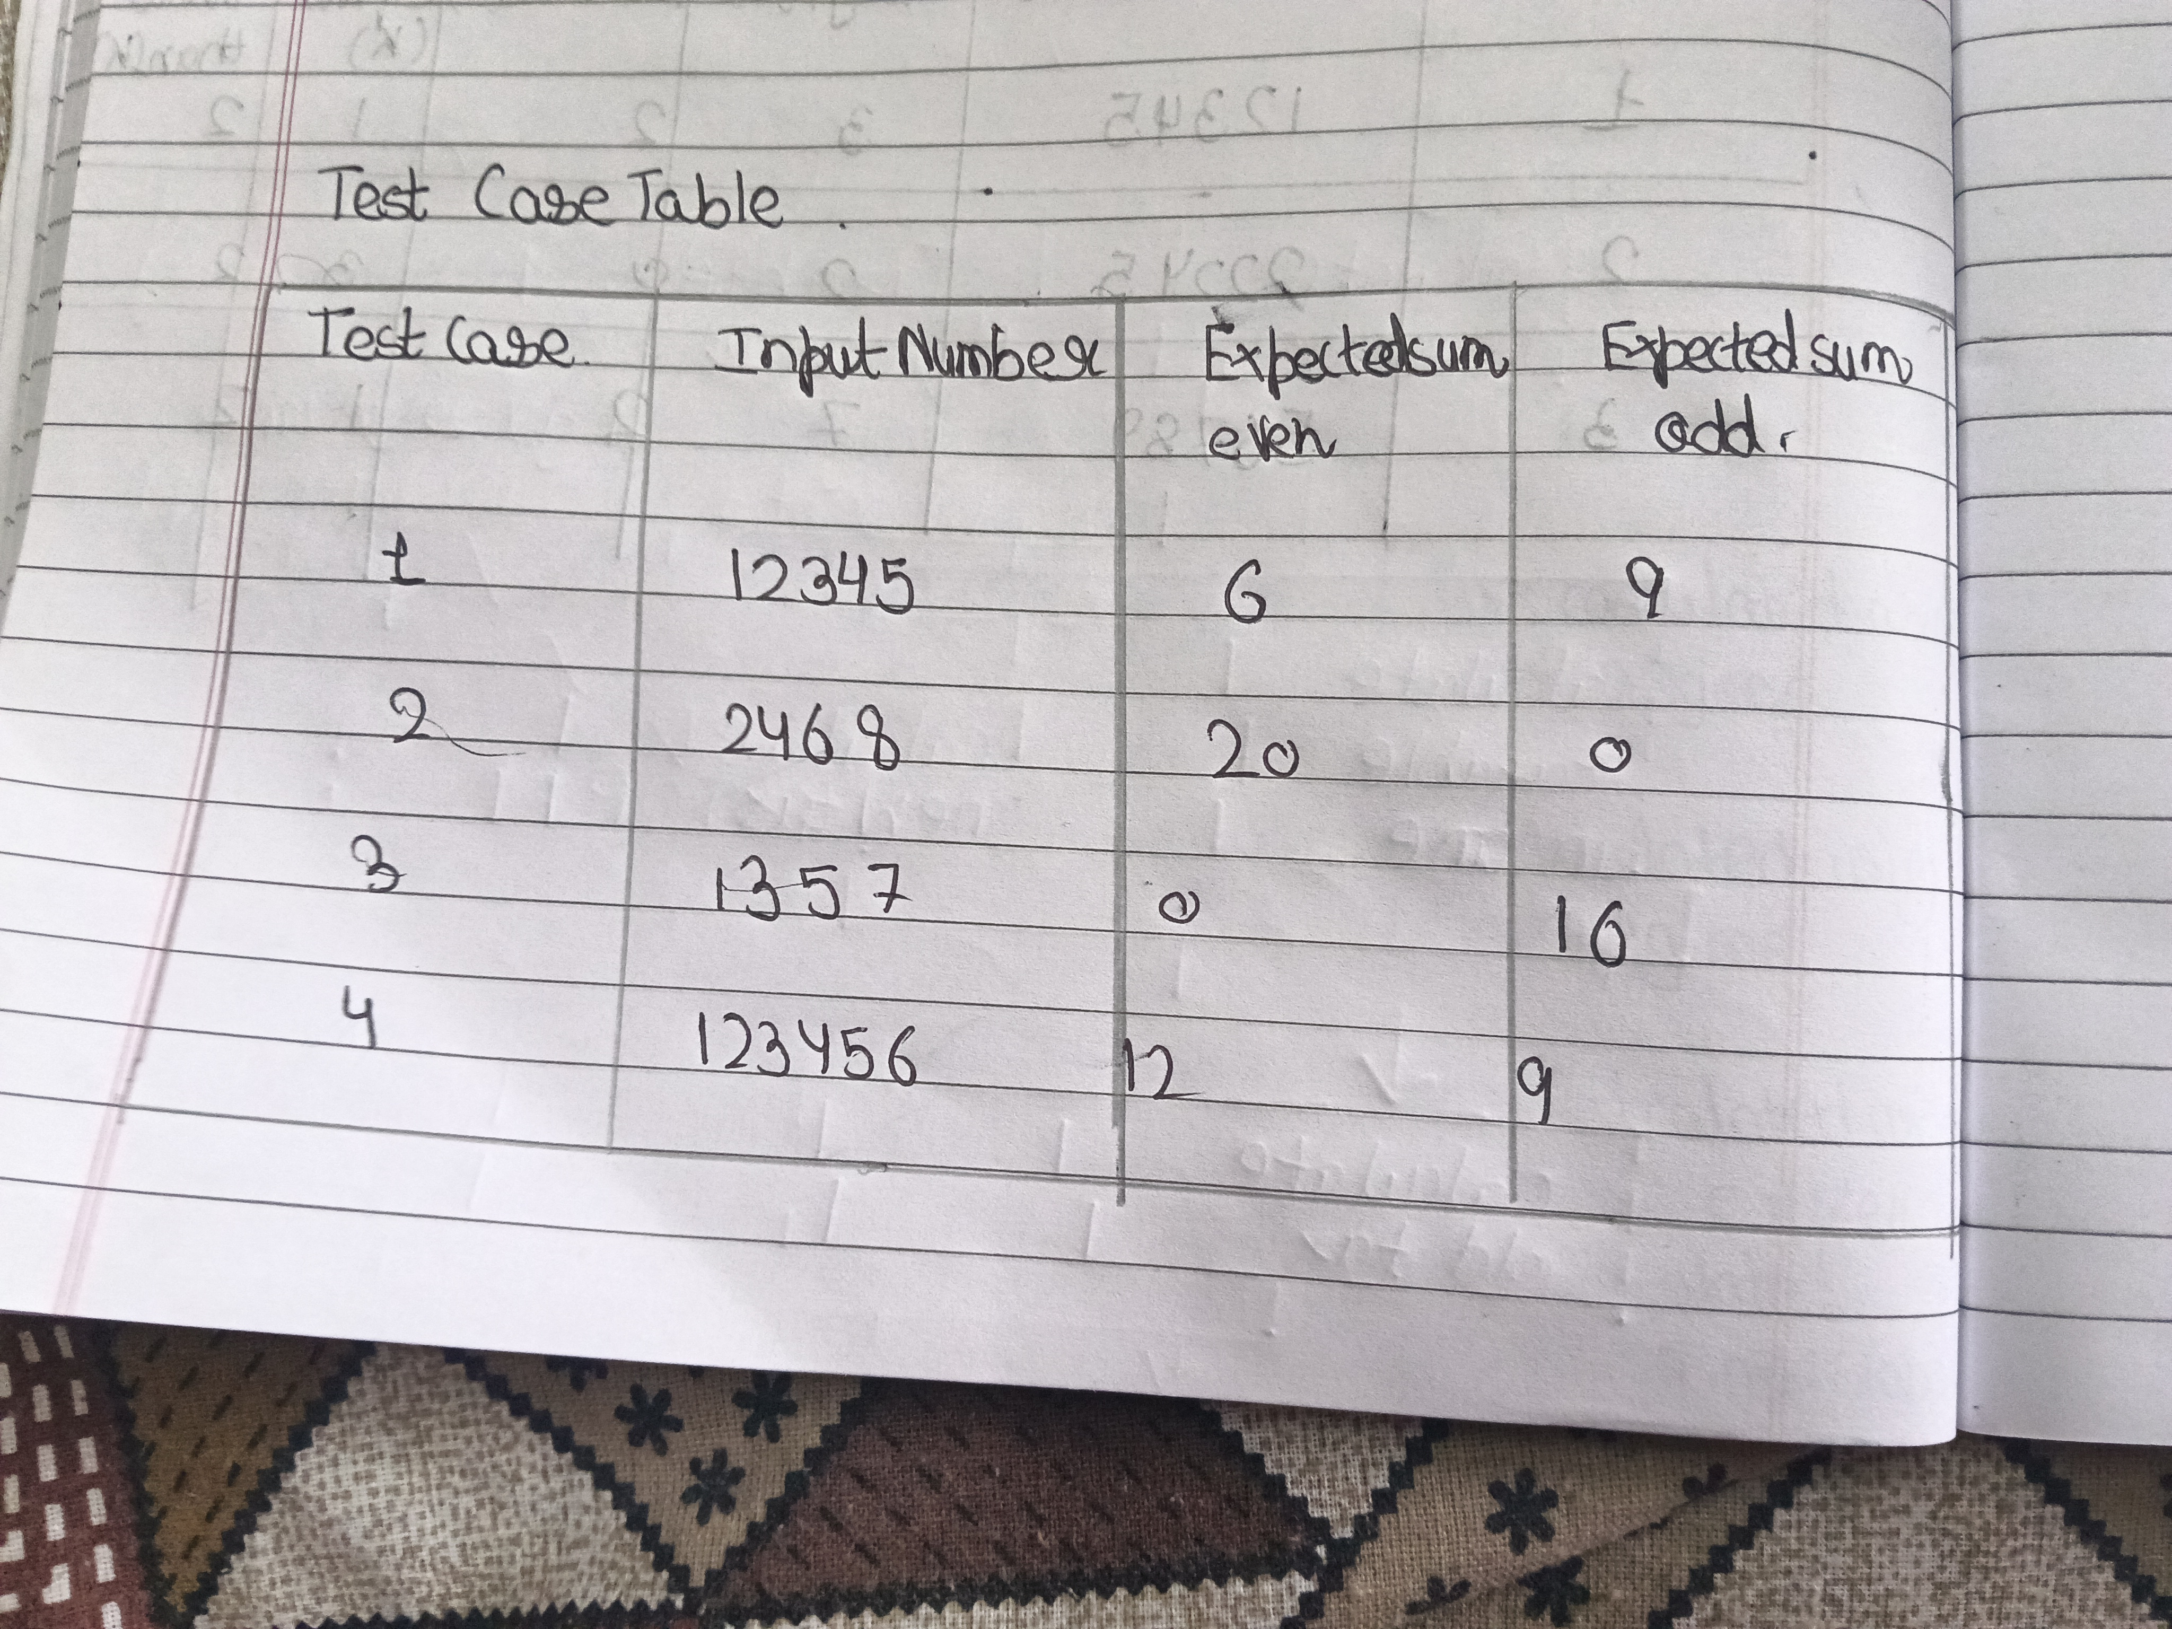
C code
#include <stdio.h>

int main()
{
int n, d, even=0, odd=0;

printf("Enter number: ");
scanf("%d", &n);

while(n>0)
{
d=n%10;

if(d%2==0)
even=even+d;
else
odd=odd+d;

n=n/10;
}

printf("Sum even = %d\n", even);
printf("Sum odd = %d\n", odd);

return 0;
}

Result
The program was successfully executed and the sum of even digits and odd digits was calculated separately.
For 12345:
Sum of even digits = 6
Sum of odd digits = 9
Thank you
Pragya pandey
Sap id 590034352
Batch 15

